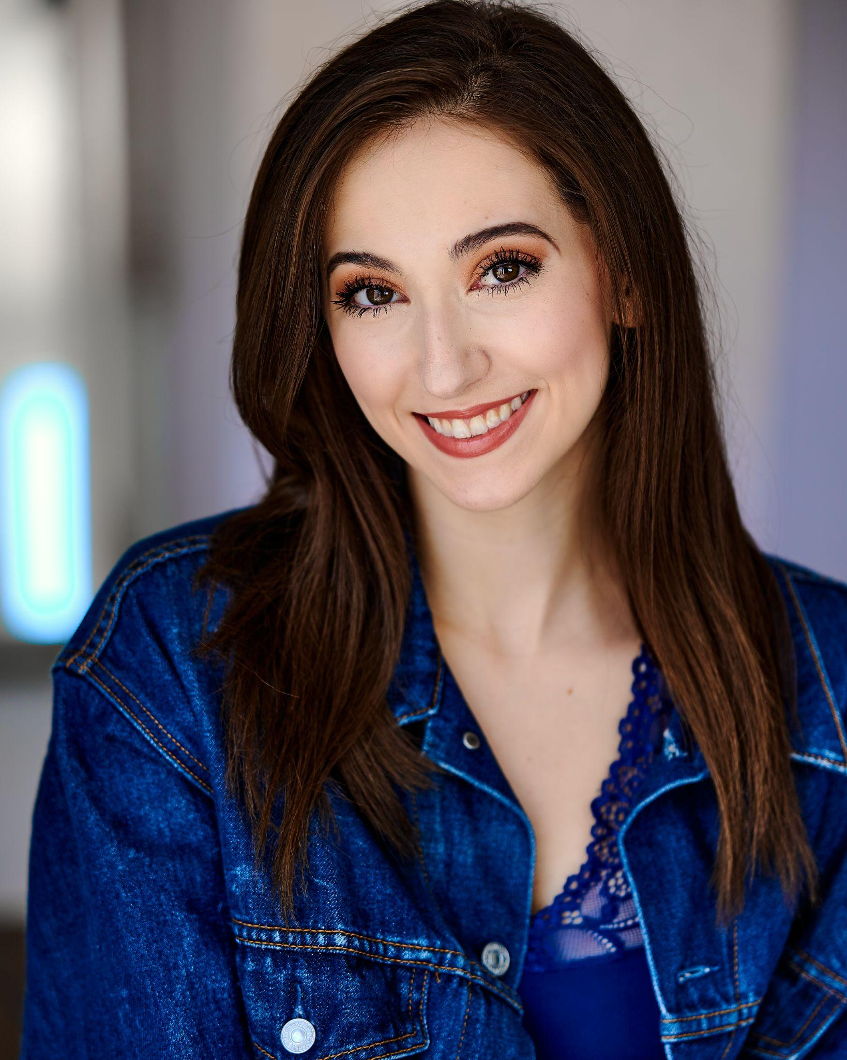 **GINA MARIE INCANDELA**

**| Email: ginamarieincandela1@gmail.com | Instagram: @gina_incandela |**

**| Website: www.**[**ginamarieincandela**](mailto:ginamarieincandela1@gmail.com)**.com |**

**Hair:** Brown  **Eyes:** Brown  **Height:** 5’7 **Vocal Range:** Mezzo/Soprano **(**F3-C6)

**Cruise Ships**

BURN THE FLOOR* Principal Vocalist Norwegian Epic-Creative Studios by NCLH

The Broadway Series: 80’s Edition* Principal Vocalist Norwegian Epic-Creative Studios by NCLH

The Welcome Aboard Show* Principal Vocalist Norwegian Epic-Creative Studios by NCLH

**\*** = Vocal Captain

**Educational Theatre**

The Spitfire Grill Shelby Nazareth University | Bryanda Minix

The Last Five Years *Selections Cathy Nazareth University | Trey Compton

The Tempest *Selections Caliban Shakespeare’s Globe | Peter Hamilton Dyer

Firebringer Claire, U/S Jemilla Nazareth University | Alexa Powell

**Workshops**

A Girl Named Bernie Ensemble Nazareth University | Christine O’Grady

(Ben Moss, Tony Oblen, Christopher Recker)  **Education**

Nazareth University BFA Musical Theatre Program Directors: Richard Biever,

Nicolette Hart, Christine O’Grady, Corinne Aquilina

London Immersion Program

*Shakespeare’s Globe* Teachers: Peter Hamilton Dyer, Alex Bingley, Yarit Dor, Hanh Bui

*West End On Demand*   Teachers: Amy Ross, Julie Gossage, Andre Fabian Francis,

Rachel Bingham

**Cabarets**

Joseph Thor and Friends Vocalist 54 Below

Seth’s Cabaret Vocalist Don’t Tell Mama’s

**Training**

**Voice:** Sean Michael Flowers, Julie Gossage, Christina Gill, Alex

Bingley, Nicolette Hart, Tim Evanicki, Sue Cotroneo

**Acting:** Trey Compton, Amy Ross, Peter Hamilton Dyer,

Nicolette Hart, Matthew Ames, David Hadinger, Patricia Browne

**Dance:** Bekka Bennett, Andre Fabian Francis,Yarit Dor,

Jay Armstrong Johnson, Tug Watson, Michael Deeb Weaver

**Masterclasses**

Benton Whitley, Jimmy Larkin, Kerry Ellis, Gary Lloyd, Michael Cassara, Krystina Alabado, Ollie Metzler, Charles Rhurmund, Lucy Jane Adcock, Wade Lewin, Francesca Ellis, Laura Osnes

*The College Audition Conservatory* with Tim Evanicki (As a Residential Advisor and Student)

**Skills**

Vocal Versatility (MT, Pop, Rock, Country, Semi-Classical, Riffs/Runs), Solid Harmonization Skills, Swift Adaptability, Strong Emotional Intelligence, CPR Certified, Driver’s Licence, Passport, Fully Vaccinated and Boosted, Good with Children and Animals, Thrift-Shopping Expert, Thoughtful Card Writer, Neurodivergent (Autistic-Spectrum)